Credit Risk Prediction using Machine Learning

Executive Summary

This project develops and compares three supervised machine learning models to predict loan default using borrower and loan characteristics. Among the evaluated models, Random Forest demonstrated the strongest predictive performance and was selected as the final classifier for credit risk assessment.

1. Introduction

Background
Credit risk refers to the possibility that a borrower will fail to meet their debt repayment obligations, resulting in financial losses for lending institutions. Accurate assessment of credit risk is therefore a critical component of banking and financial decision-making. Traditionally, credit evaluation relied heavily on manual assessment of borrower profiles. However, the increasing availability of financial data has enabled the use of machine learning techniques to support faster, more consistent, and data-driven lending decisions.

Problem Statement
Financial institutions must evaluate thousands of loan applications while balancing profitability with credit risk. Incorrect lending decisions can lead to significant financial losses through borrower defaults, whereas overly conservative lending may result in the rejection of creditworthy applicants. Developing predictive models that accurately identify high-risk loan applications can improve credit assessment and support more informed lending decisions.

Project Objective
The objective of this project is to develop and compare multiple supervised machine learning models for predicting loan default using borrower and loan characteristics. Specifically, the study compares Logistic Regression, Decision Tree, and Random Forest classifiers, evaluates their predictive performance using standard classification metrics, and identifies the most suitable model for credit risk prediction.

Dataset Description
The analysis uses the Credit Risk Dataset developed by Lao Tse, obtained from Kaggle. The dataset contains 32,581 loan applications, each described by 12 variables representing borrower demographics, employment characteristics, credit history, and loan-specific attributes. The target variable, loan_status, indicates whether a loan eventually defaulted (1) or was successfully repaid (0).
The dataset includes variables such as borrower age, annual income, employment length, home ownership status, loan purpose, loan grade, loan amount, interest rate, loan-to-income ratio, previous default history, and credit history length. Together, these variables provide a comprehensive view of the factors that may influence credit risk.

Dataset Summary
Attribute | Description
Dataset | Credit Risk Dataset (Lao Tse)
Source | Kaggle
Number of Observations | 32,581
Number of Variables | 12
Target Variable | loan_status
Prediction Task | Binary Classification
Class Labels | 0 = Non-default, 1 = Default

Figure 1. Distribution of Loan Status
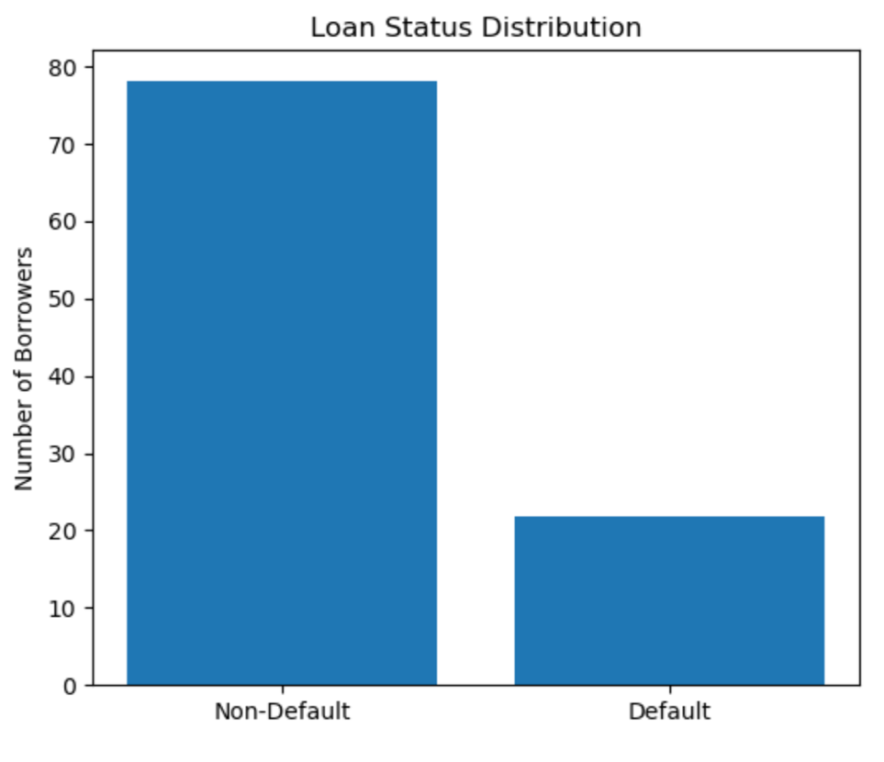
Figure 1: Distribution of loan applications by repayment status. Approximately 78% of loans were successfully repaid, while 22% eventually resulted in default, indicating a moderate class imbalance in the dataset.

2. Data Preparation & Exploratory Data Analysis

Data Preparation
Prior to model development, the dataset underwent a structured preprocessing pipeline to improve data quality and ensure compatibility with machine learning algorithms. An initial inspection identified 165 duplicate loan records, which were removed to prevent repeated observations from biasing the learning process. Additionally, five observations containing borrower ages greater than 100 years were excluded, as these values were considered implausible in the context of retail lending.
Missing values were handled using median imputation for numerical variables and mode imputation for categorical variables to preserve the dataset while minimizing the influence of extreme values. Categorical variables were subsequently transformed into numerical representations using One-Hot Encoding, after which the dataset was divided into training and testing subsets using an 80:20 stratified split. Finally, numerical predictor variables were standardized using StandardScaler to ensure consistent feature scales for model training.

Exploratory Data Analysis
Exploratory Data Analysis was conducted to understand borrower characteristics, loan attributes, and their relationship with loan default. Several meaningful patterns emerged from the analysis:
- Approximately 78% of loans were successfully repaid, while 22% resulted in default, indicating a moderate class imbalance.
- Loan default rates increased substantially for lower credit grades, suggesting that loan grade is a strong indicator of borrower risk.
- Borrowers who eventually defaulted generally exhibited higher interest rates, reflecting risk-based pricing by lenders.
- Correlation analysis showed that the loan-to-income ratio and interest rate had the strongest positive associations with loan default among the numerical variables, although the overall relationships remained moderate.
These findings provided valuable business insights while also informing expectations regarding the predictive importance of variables in the subsequent machine learning models.

Figures

Figure 2. Correlation Matrix of Numerical Variables
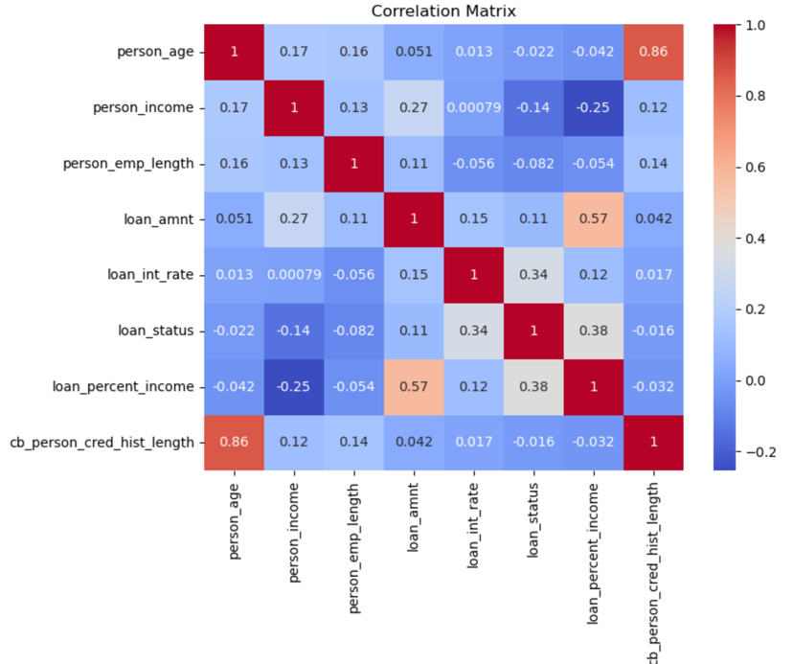
Figure 2: Pearson correlation matrix illustrating relationships among numerical variables. The strongest positive correlation with loan default is observed for the loan-to-income ratio (0.38), followed by the interest rate (0.34), suggesting that borrowers with larger repayment burdens and higher borrowing costs exhibit greater default risk.

Figure 3. Default Rate by Loan Grade
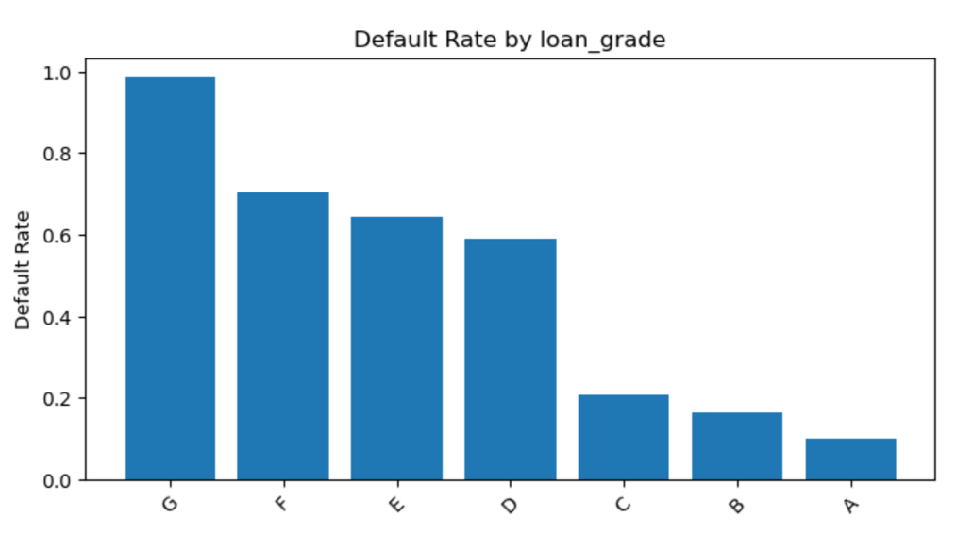

Figure 3: Default rates increase sharply as loan grades deteriorate from Grade A to Grade G. Borrowers assigned lower credit grades exhibit substantially higher default frequencies, confirming loan grade as one of the most informative indicators of credit risk.

Figure 4. Interest Rate Distribution by Loan Status
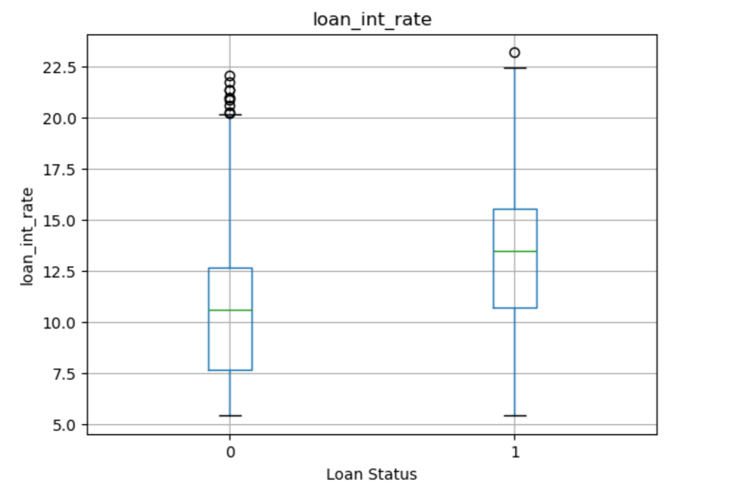
Figure 4: Borrowers who defaulted generally received loans with higher interest rates than those who successfully repaid their loans. This pattern is consistent with risk-based lending, where borrowers perceived as riskier are charged higher borrowing costs.
The insights obtained through exploratory analysis suggest that several borrower and loan characteristics possess meaningful predictive value. These variables are subsequently used to train and compare multiple supervised machine learning models for loan default prediction.

3. Machine Learning Methodology

Model Development
The objective of the modelling stage was to predict whether a loan application would eventually default based on borrower demographics, financial characteristics, and loan attributes. Since the target variable (loan_status) contains two possible outcomes—Default (1) and Non-default (0)—the problem was formulated as a binary classification task.
Three supervised machine learning algorithms of increasing complexity were implemented and compared:
- Logistic Regression – a probabilistic linear classifier that estimates the probability of loan default.
- Decision Tree – a non-linear classifier that recursively partitions the feature space into homogeneous groups using decision rules.
- Random Forest – an ensemble learning algorithm that combines multiple decision trees through bootstrap aggregation and majority voting to improve predictive performance and reduce overfitting.
Using multiple algorithms allowed the study to compare models with different underlying assumptions and identify the most suitable approach for credit risk prediction.

Model Training Workflow
Each algorithm followed the same modelling pipeline to ensure a fair comparison:
- Train the model using the preprocessed training dataset.
- Predict loan status for the unseen testing dataset.
- Estimate the probability of default for each loan application.
- Evaluate model performance using multiple classification metrics.
- Compare all models and select the best-performing classifier.
Using an identical workflow ensures that differences in predictive performance arise from the algorithms themselves rather than differences in data preparation.

Model Evaluation
Since loan default prediction is a classification problem, regression metrics such as Mean Squared Error (MSE) and Root Mean Squared Error (RMSE) are not appropriate. Instead, model performance was evaluated using classification metrics that assess different aspects of predictive ability:
Metric | Purpose
Accuracy | Overall proportion of correctly classified loan applications
Precision | Proportion of predicted defaulters that actually defaulted
Recall | Proportion of actual defaulters correctly identified
F1-score | Harmonic mean of Precision and Recall
ROC-AUC | Overall ability of the model to distinguish between defaulting and non-defaulting borrowers across all probability thresholds

Among these metrics, ROC-AUC was selected as the primary criterion for model comparison because it evaluates the ranking ability of the classifier independently of any single probability threshold.

Following model development, the predictive performance of the three classifiers was systematically compared using multiple evaluation metrics to identify the most effective model for credit risk prediction.

4. Model Performance & Results

Model Comparison
Three supervised machine learning algorithms were trained and evaluated for loan default prediction: Logistic Regression, Decision Tree, and Random Forest. Their predictive performance was assessed using Accuracy, Precision, Recall, F1-score, ROC-AUC, and training time.
As shown in Table 2, the Random Forest classifier consistently outperformed the other models across nearly all evaluation metrics. It achieved the highest Accuracy (93.40%), Precision (96.00%), F1-score (82.84%), and ROC-AUC (0.929) while maintaining competitive Recall (72.85%). Although Random Forest required a longer training time than the other algorithms, the additional computational cost was relatively small and justified by the substantial improvement in predictive performance.
Logistic Regression provided a strong baseline model with good discrimination (ROC-AUC = 0.867), whereas the Decision Tree achieved the highest Recall (76.16%) but exhibited weaker overall classification performance due to lower Precision and ROC-AUC.
Consequently, Random Forest was selected as the final model for business interpretation and deployment.

Table 1. Performance Comparison of Machine Learning Models
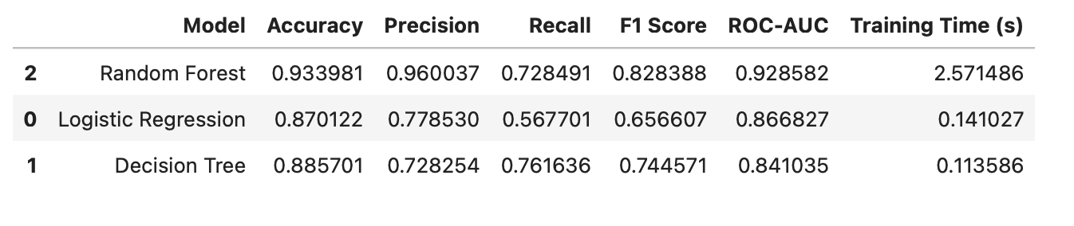
Table 1: Comparative performance of the three classification algorithms. Random Forest achieved the strongest overall predictive performance and was selected as the final classifier.

Feature Importance Analysis
To improve model interpretability, the relative contribution of each predictor variable was examined using the feature importance scores produced by the Random Forest model.
As illustrated in Figure 5, the loan-to-income ratio (loan_percent_income) emerged as the most influential predictor of loan default, followed by borrower income, loan interest rate, and loan amount. Variables related to borrower financial capacity consistently ranked above demographic characteristics, indicating that financial indicators play a more important role in predicting repayment behaviour than personal attributes alone.
Interestingly, encoded categorical variables such as loan grade and home ownership status also appeared among the ten most important predictors, demonstrating that both borrower characteristics and loan-specific attributes contribute to credit risk assessment.

Figure 6. Top 10 Feature Importances
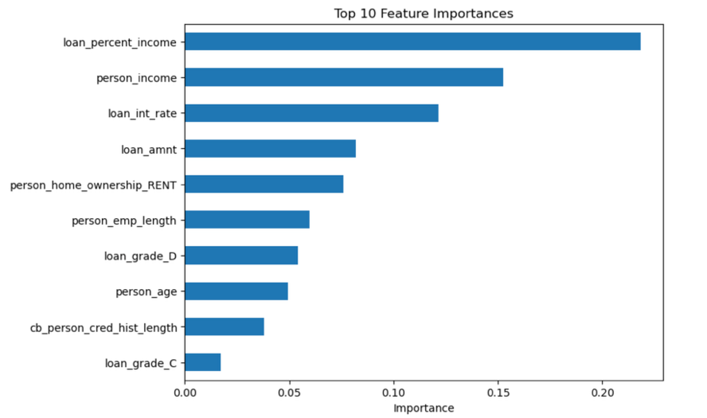
Figure 6: Relative importance of predictor variables in the Random Forest model. The loan-to-income ratio, borrower income, and loan interest rate were identified as the most influential determinants of loan default.

ROC Curve Analysis
The Receiver Operating Characteristic (ROC) curve further confirmed the superior discriminatory ability of the Random Forest classifier.
With an Area Under the Curve (ROC-AUC) of 0.929, Random Forest demonstrated an excellent ability to distinguish between borrowers who eventually defaulted and those who successfully repaid their loans. Compared with Logistic Regression (0.867) and Decision Tree (0.841), the Random Forest model consistently achieved a higher True Positive Rate across a wide range of False Positive Rates, indicating stronger overall classification performance.

Figure 7. ROC Curve Comparison
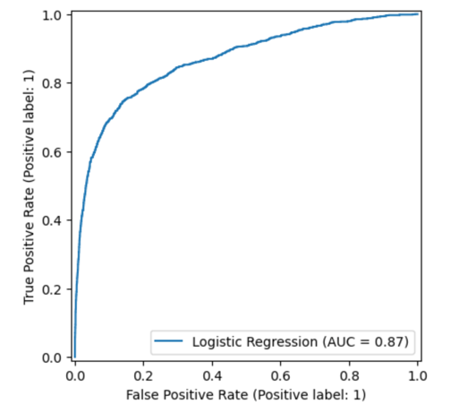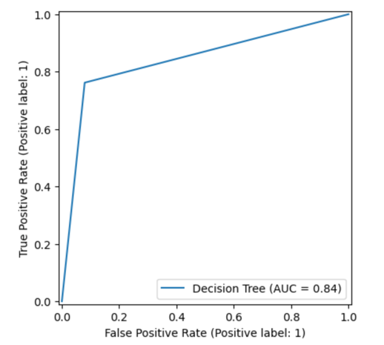

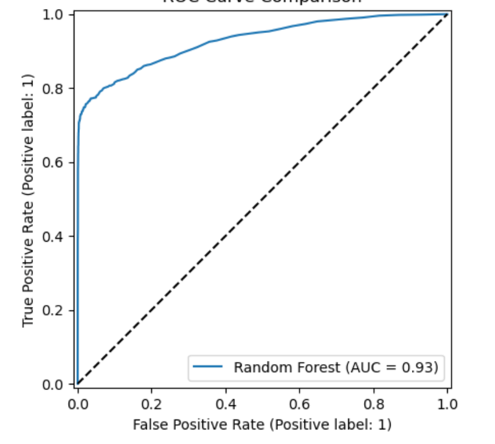
Figure 7: ROC curve comparison for the three machine learning models. Random Forest achieved the highest Area Under the Curve (ROC-AUC = 0.929), indicating the strongest overall ability to discriminate between defaulting and non-defaulting borrowers.

Key Findings
- Random Forest achieved the best overall predictive performance, with a ROC-AUC of 0.929, making it the preferred model for credit risk prediction.
- Logistic Regression provided a competitive baseline model with good discriminatory power but lower Recall and F1-score.
- Decision Tree identified a larger proportion of defaulting borrowers but sacrificed Precision and overall classification performance.
- Financial variables—particularly loan-to-income ratio, borrower income, and interest rate—were the strongest predictors of loan default.
- The results demonstrate that ensemble learning methods can substantially improve predictive accuracy while maintaining strong interpretability through feature importance analysis.
Having identified Random Forest as the best-performing classifier, the final stage of the analysis focuses on interpreting individual predictions and evaluating the business implications of model errors in a credit risk management context.

5. Business Insights & Recommendations

Model Interpretation
While predictive performance provides an indication of model quality, the practical value of a credit risk model lies in its ability to support lending decisions. The selected Random Forest classifier was therefore further examined through its confusion matrix, individual loan predictions, and prediction errors.
The confusion matrix provides a detailed summary of correct and incorrect classifications, allowing the strengths and limitations of the model to be interpreted from a business perspective.

Figure 8. Confusion Matrix for the Random Forest Classifier

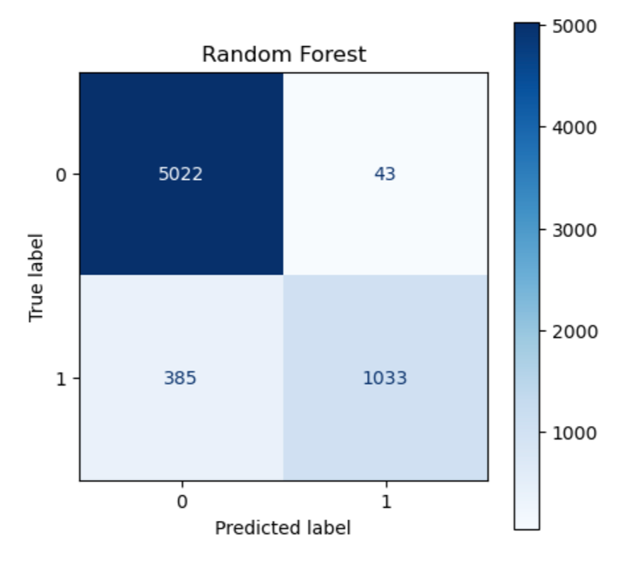
Figure 8: Confusion matrix for the Random Forest classifier. Out of 6,483 loan applications in the testing dataset, the model correctly classified 5,022 non-defaulting borrowers and 1,033 defaulting borrowers, while producing only 43 False Positives and 385 False Negatives.

Interpretation of Classification Errors
The Random Forest model correctly classified the vast majority of loan applications, achieving a particularly low number of False Positives (43). This indicates that very few creditworthy borrowers were incorrectly classified as defaulters, minimizing unnecessary loan rejections.
The model produced 385 False Negatives, representing borrowers who were predicted to repay their loans but eventually defaulted. Although this number is larger than the number of False Positives, it remains relatively small compared with the total number of observations.
From a banking perspective, the two error types have different implications:
- False Positives result in potentially profitable borrowers being denied credit, leading to lost business opportunities and reduced customer satisfaction.
- False Negatives are generally more costly because they involve approving loans that ultimately default, exposing the lender to financial losses.
The high Precision (96.0%) achieved by the Random Forest model indicates that when the model predicts a borrower will default, it is usually correct. This makes the classifier particularly valuable for identifying high-risk applicants during the credit approval process.

Individual Loan Prediction
To demonstrate practical deployment, the trained Random Forest model was applied to an unseen loan application from the testing dataset.
The model predicted the applicant to be Non-default, with an estimated Probability of Default of only 1.00%. Rather than providing only a binary classification, the model also outputs an estimated probability of default, enabling lenders to rank borrowers according to their level of risk and incorporate probability thresholds into lending policies.

Figure 9. Example Prediction
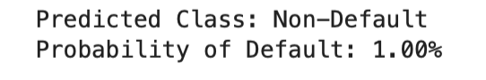
Figure 9: Example of an individual loan assessment generated by the Random Forest model. The applicant was classified as a Non-default borrower with an estimated 1.00% probability of default, indicating a very low level of predicted credit risk.

Business Recommendations
Based on the modelling results, the following recommendations are proposed:
- Use the Random Forest classifier as a decision-support tool during loan evaluation rather than a replacement for expert judgement.
- Prioritize manual review for applicants predicted to have a high probability of default before final lending decisions are made.
- Periodically retrain the model using more recent lending data to account for changing borrower behaviour and economic conditions.
- Complement the model with additional financial and behavioural variables, such as credit scores or repayment history, to further improve predictive performance.
Overall, the developed Random Forest classifier demonstrated strong predictive capability and practical applicability for credit risk assessment. The final section summarizes the key findings of the study, discusses its limitations, and outlines potential directions for future research.

6. Conclusion
This project developed and evaluated three supervised machine learning models—Logistic Regression, Decision Tree, and Random Forest—for predicting loan default using borrower demographics, financial characteristics, and loan-specific information.
After systematically comparing the models using multiple classification metrics, the Random Forest classifier emerged as the best-performing model, achieving an Accuracy of 93.40%, Precision of 96.00%, and an excellent ROC-AUC score of 0.929. Feature importance analysis further demonstrated that financial variables, particularly the loan-to-income ratio, borrower income, and interest rate, play a central role in predicting credit risk.
The results indicate that machine learning techniques can effectively support credit risk assessment by identifying borrowers with a higher probability of default while maintaining strong predictive performance.

Key Contributions
The project successfully demonstrated:
- A complete end-to-end machine learning workflow for credit risk prediction.
- Systematic data preprocessing, including duplicate removal, missing value treatment, categorical encoding, and feature scaling.
- Comparative evaluation of three widely used classification algorithms.
- Interpretation of model predictions using feature importance and confusion matrix analysis.
- Translation of technical model outputs into practical recommendations for credit risk management.

Limitations
Although the developed model performed well, several limitations should be acknowledged:
- The dataset contains a limited number of borrower attributes and does not include variables such as credit scores, repayment history, outstanding debt, or macroeconomic indicators that may further improve prediction accuracy.
- The analysis is based on a single historical dataset and therefore may not fully capture changes in borrower behaviour under different economic conditions.
- The Random Forest model, while highly accurate, provides lower interpretability than simpler statistical models such as Logistic Regression.

Final Remarks
The findings of this study demonstrate that machine learning provides an effective framework for credit risk prediction by combining borrower characteristics and loan attributes to estimate the likelihood of default. Among the evaluated models, Random Forest delivered the strongest predictive performance and showed considerable potential as a decision-support tool for financial institutions. While such models should complement rather than replace expert judgement, they can contribute to more consistent lending decisions, improved risk management, and reduced default-related losses.

